The UML Design Modeling paper
Madjany Lamour
University of Arizona Global Campus
CST 499: Capstone for Computer Software Technology
Professor Joseph Rangitsch
May 26, 2025

Unified Modeling Language (UML) diagrams are powerful tools for visualizing the structure and behavior of a software system. For the online course registration and enrollment system for the Software Requirements Specification (SRS), UML diagrams help clarify design decisions and guide implementation.
The use case diagram shows the main actor (the Student) and the core system functions, which include registering an account, logging in, seeing available courses, signing up for a course, joining a waitlist, and canceling enrollment. This is how the student interacts with various parts of the model.
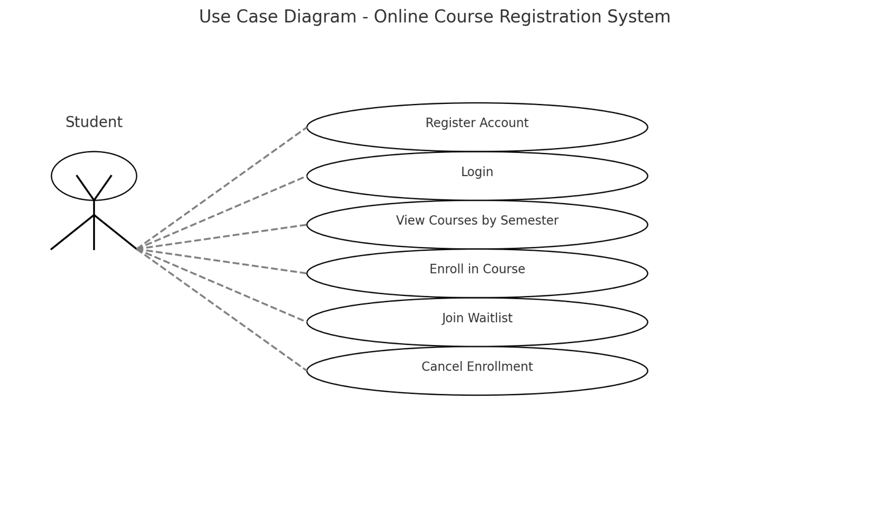

The basic layout of the system is shown by the class diagram. It has classes like Waitlist, User, Course, Semester, Enrollment, and Course. These classes are linked by associations, which show connections like registration and course options. There are properties (like courseID and userID) and functions (like enroll() and cancel()) in each class.
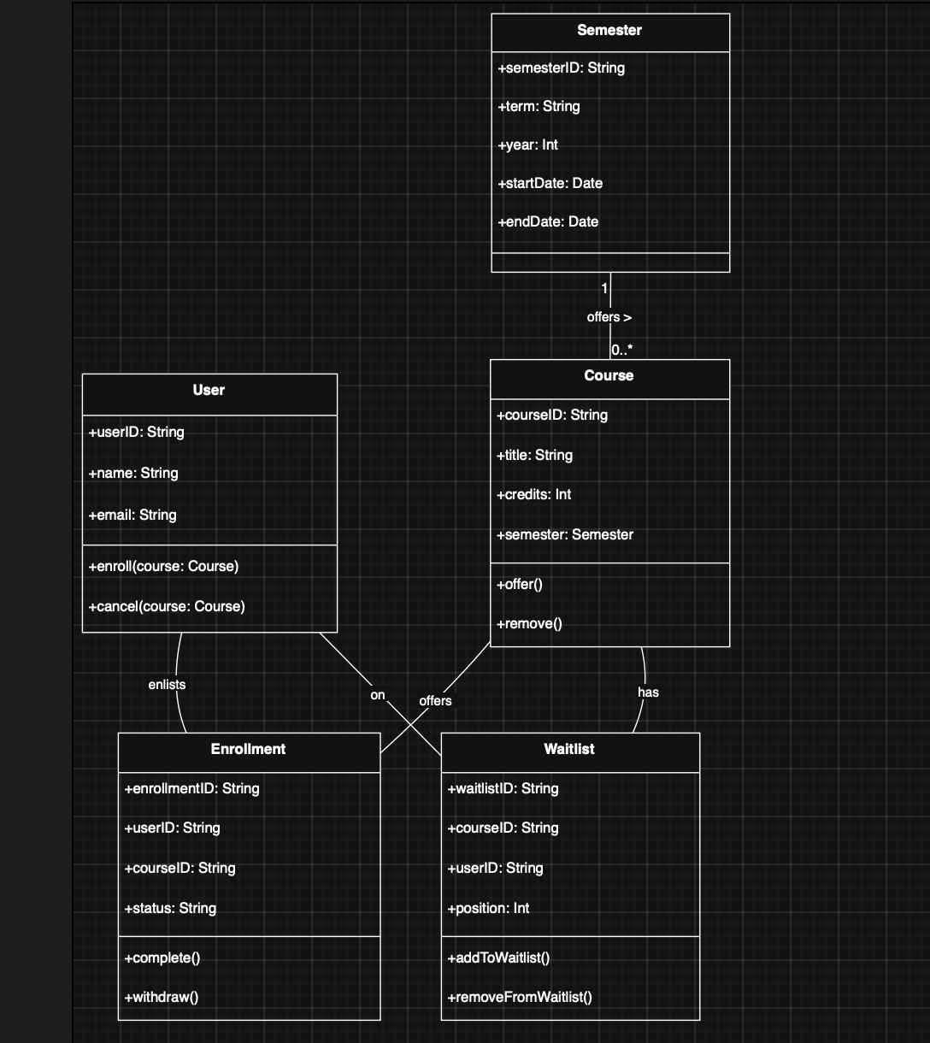

The sequence diagram shows how the steps in the registration process work together. It displays the order of the messages sent between the Waitlist, the Course object, the Enrollment manager, and the Student. The flowchart shows how things happen, like checking to see if a course is full, confirming registration, and changing the state of a waitlist.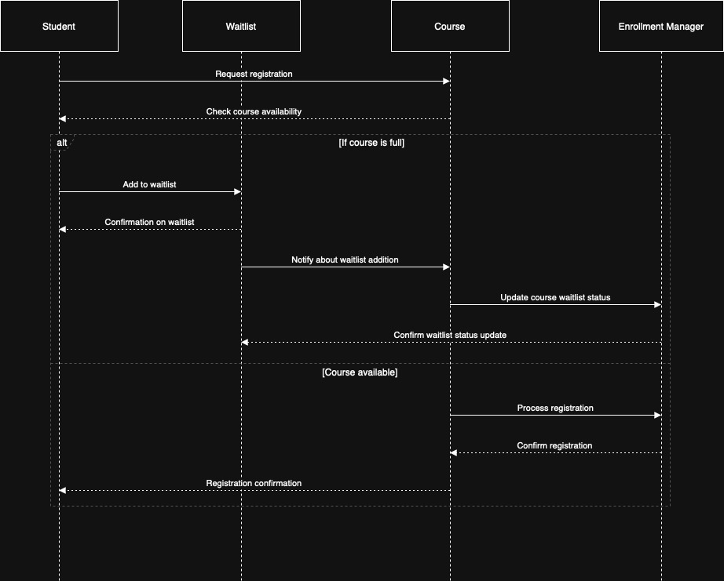

The activity diagram shows the steps a user takes to sign up for a course. To get started, you need to log in, choose a semester, look at the course selections, then either sign up for the course right away or join the waitlist if it is full.
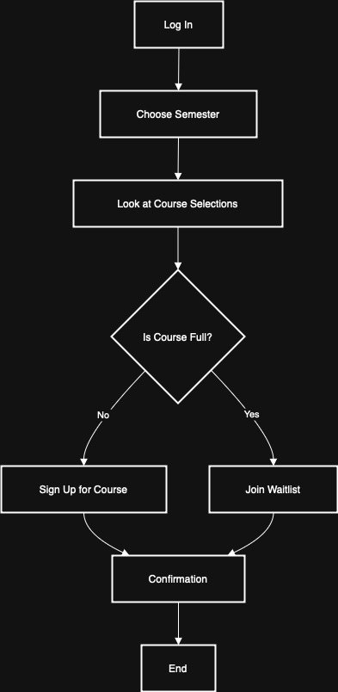
The state diagram shows the lifecycle of a course object. A course may start in an Open state, transition to Full when the maximum enrollment is reached, move to Waitlisted if students join a queue, and return to Open if a spot opens due to cancellation.
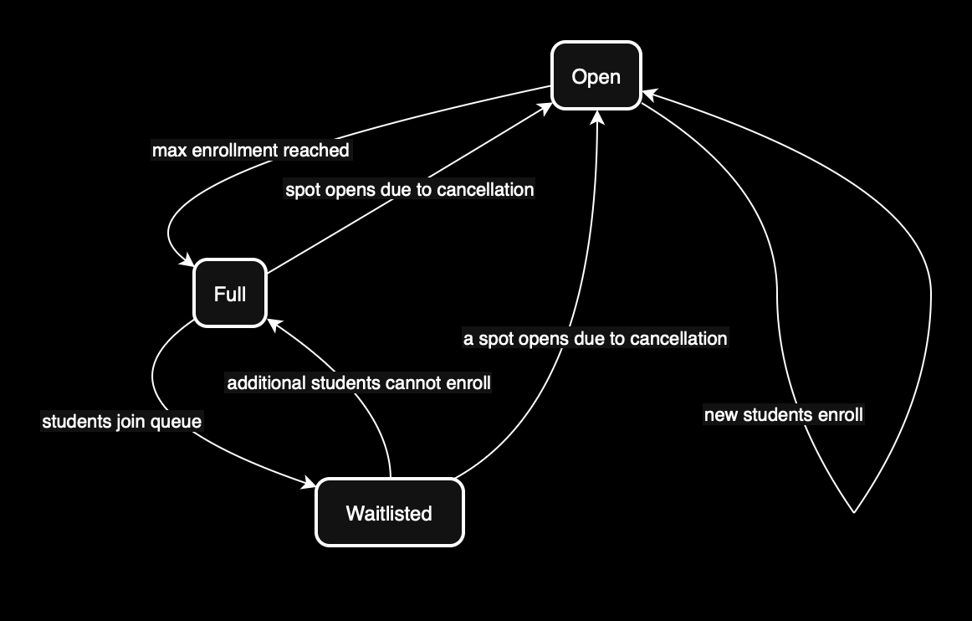

There are different levels of software testing to ensure that the system functions reliably and meets user requirements. The main goal of component testing is to test separate sections or parts. For instance, the registration function should be checked to make sure that it saves user data properly and requires unique user IDs.
Integration testing checks how different parts work together. For example, integrated testing would make sure that the user can log in and interact with course data after successfully registering. During system testing, the SRS is checked against the whole, combined system. Testers would pretend to be users and do things like sign up, stop, and check the progress of a course on different browsers and devices. Real people test the system to make sure it meets business needs during Acceptance Testing. It makes sure that the system works well for registration, admission, managing waitlists, and sending out notices on time.

References:
Tsui, F., Karam, O., & Bernal, B. (2018). Essentials of software engineering (4th ed.). Jones & Bartlett Learning.

Aldaeej, A., & Badreddin, O. (2016, May 14–22). Towards promoting design and UML modeling practices in the open source communityLinks to an external site.[Paper presentation]. 2016 IEEE/ACM 38th International Conference on Software Engineering Companion (ICSE-C), Austin, TX, United States. https://doi.org/10.1145/2889160.2892649

Chidamber, S. R., & Kemerer, C. F. (1994). A metrics suite for object oriented design. IEEE Transactions on Software Engineering, 20(6), 476–493. https://doi.org/10.1109/32.295895

OMG Unified Modeling Language. (2023). UML 2.5.1 specification. Object Management Group. https://www.omg.org/spec/UML/2.5.1/

